| **Test Name** | | Add error to system | | | |
| --- | --- | --- | --- | --- | --- |
| **Use Case Tested:** | | Use Case 9 – Add User to System (new admin user) | | | |
| **Test Description:** | | User:   * Enters new user’s login * Enters new user’s password * Enters new user’s Authentication Level * Logs out of P.E.T. * Logs in with newly created login | | | |
| **Pre-conditions** | | User has successfully logged in.  User has an auth level of administrator  Enter a User page is presented to user | | | |
| **Post-conditions** | | Database is successfully updated with the data | | | |
| **Notes:** | |  | | | |
| **Result (Pass/Fail/Warning/Incomplete)** | |  | | | |
|  | **TEST STEP** | | **EXPECTED TEST RESULTS** | P | F |
|  | Login is entered | | Login is accepted | X |  |
|  | Password is entered | | Password is accepted | X |  |
|  | Authorization level entered | | Authorization level accepted | X |  |
|  | Log out. Log in with new login | | Program loaded with correct permissions | X |  |

|  |  |  |  |  |  |
| --- | --- | --- | --- | --- | --- |
| **Test Data Table** | | | | | |
|  | **1** | **2** | **3** | **4** | **5** |
| Login: | lab-supervisor |  |  |  |  |
| Password: | sup12345 |  |  |  |  |
| Authorization level: | Administrator (2) |  |  |  |  |

A screen capture of the database to show that the entry does not yet exist:

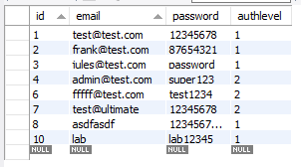

A screen capture showing the form filled out:

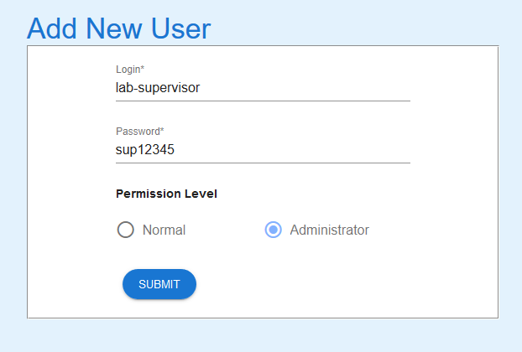

Form successfully submitted. Permission level reset to ‘Normal’ as a default setting

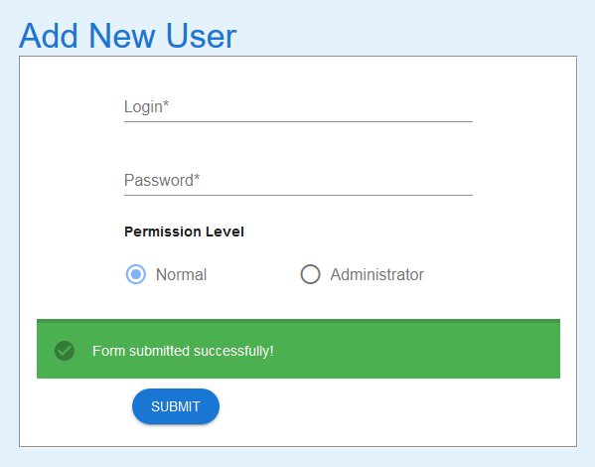

User now in the database

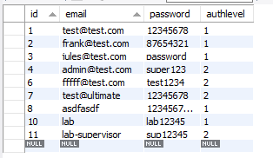

Logging in with the new credentials

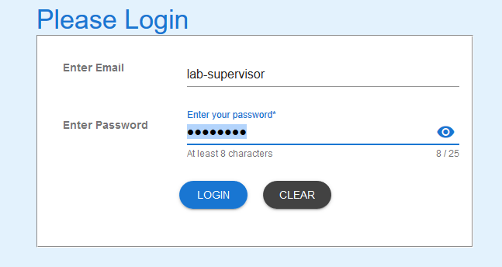

New credentials working with the proper permissions. Note how the multiple options that are available to the administrator account.

